Download the

<https://go.microsoft.com/fwlink/?LinkID=521962>

Select the **Financials** table, and choose **Transform Data**.

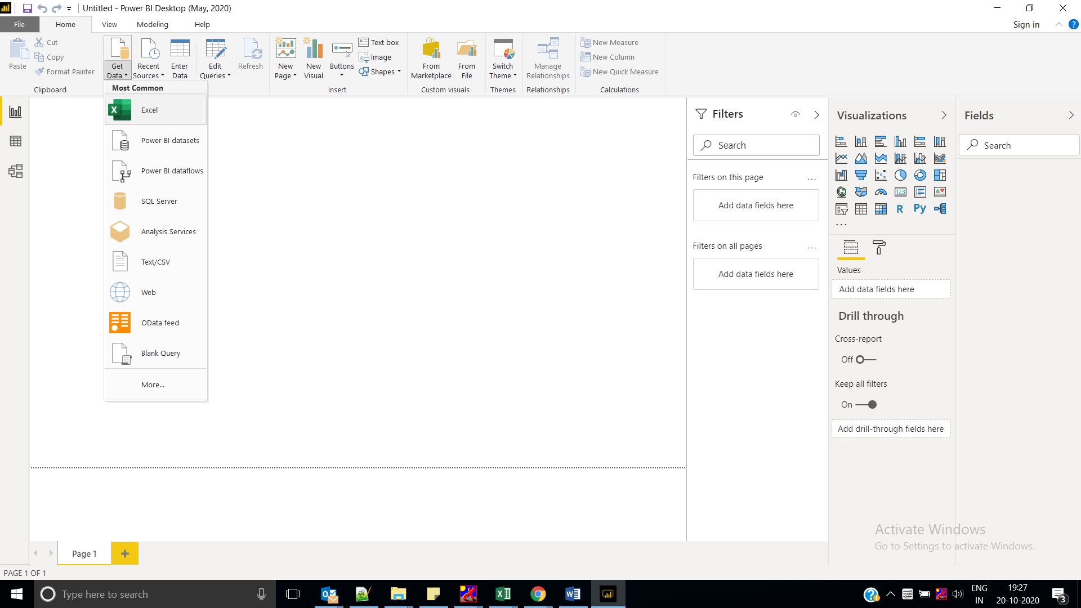

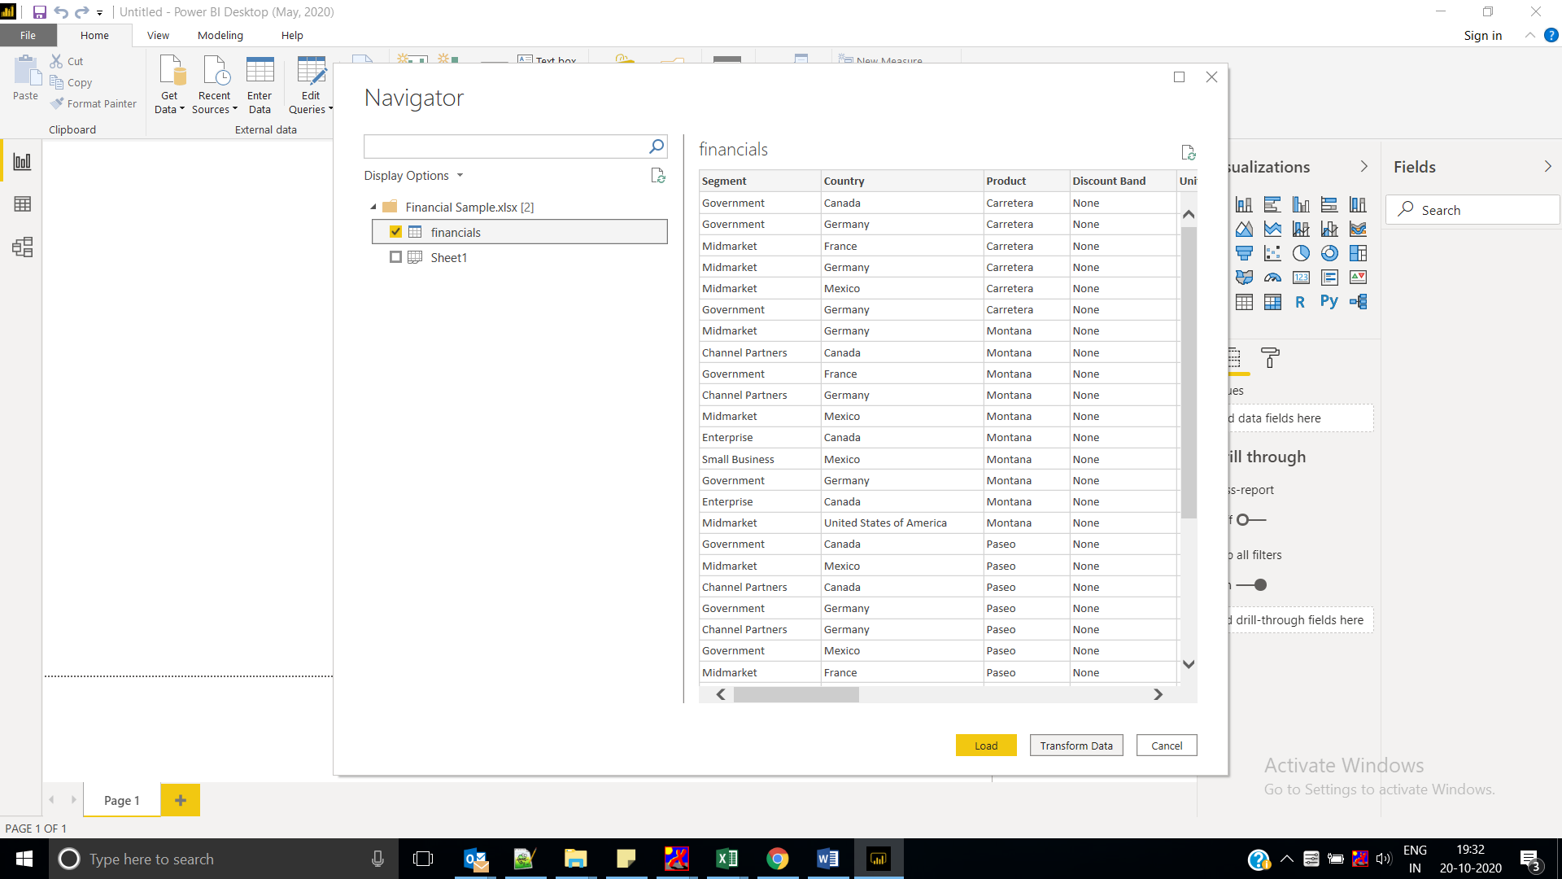

Select the **Units Sold** column. On the **Home** tab, select **Data Type**, then select **Whole Number**. Choose **Replace current** to change the column type.

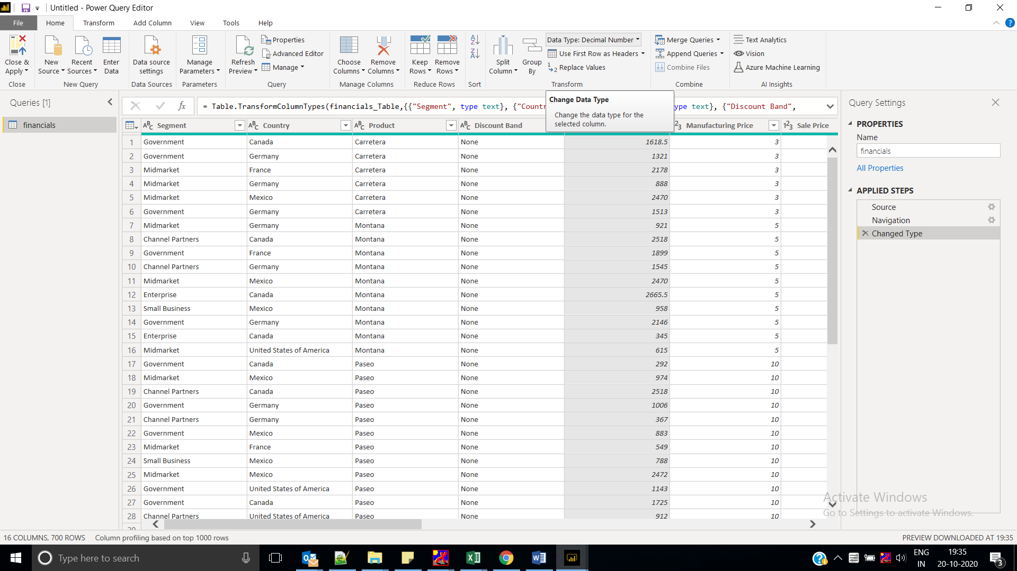

Remove decimal values

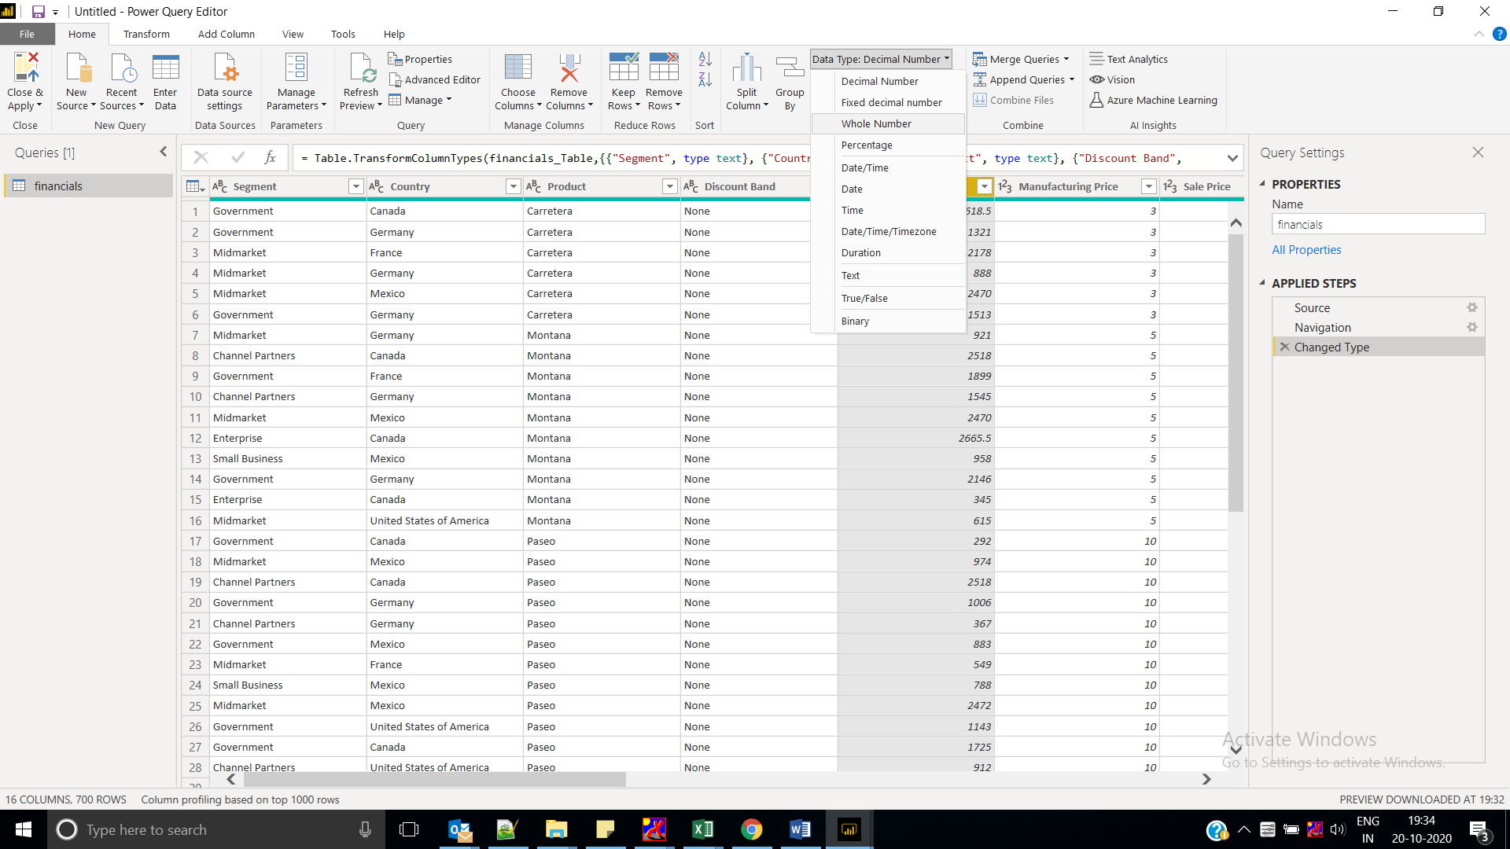

Select the **Segment** column. On the **Transform** tab, select **Format**, then select **UPPERCASE**.

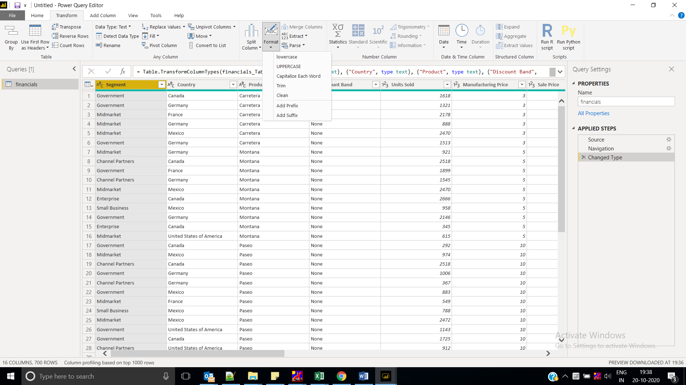

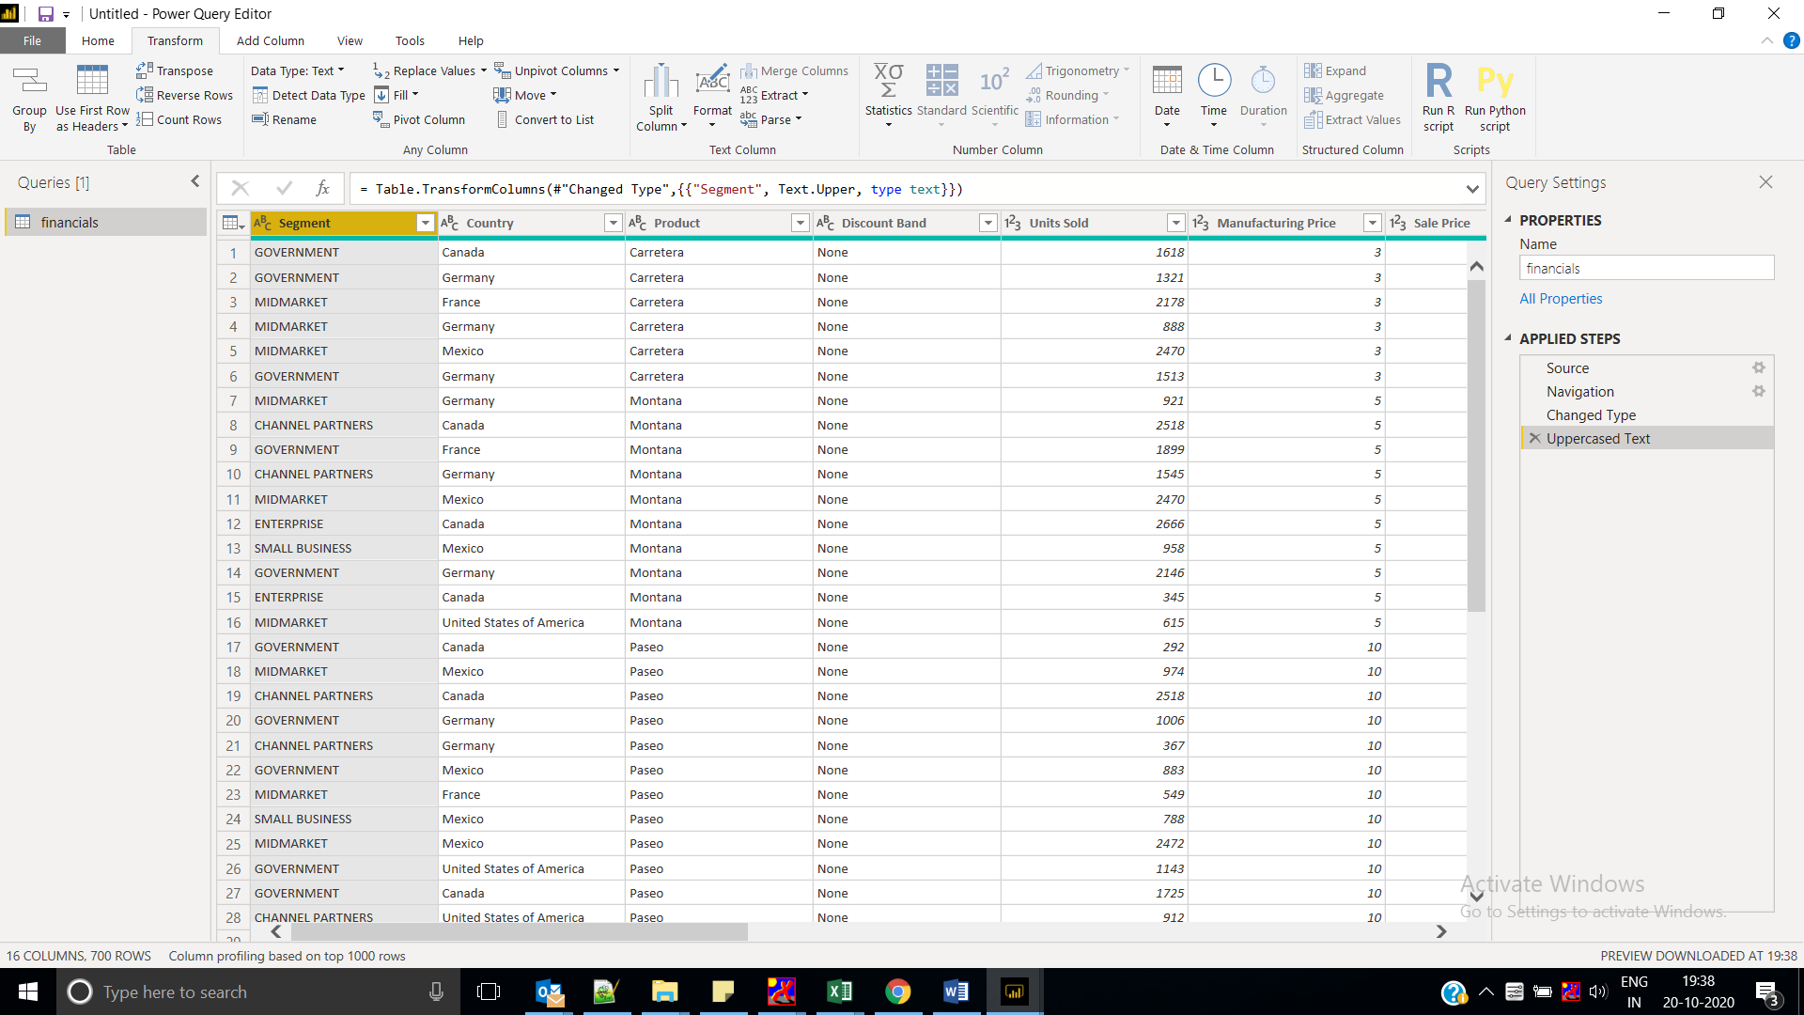

**Month Name** to just **Month**. Double-click the **Month Name** column, and rename to just **Month**.

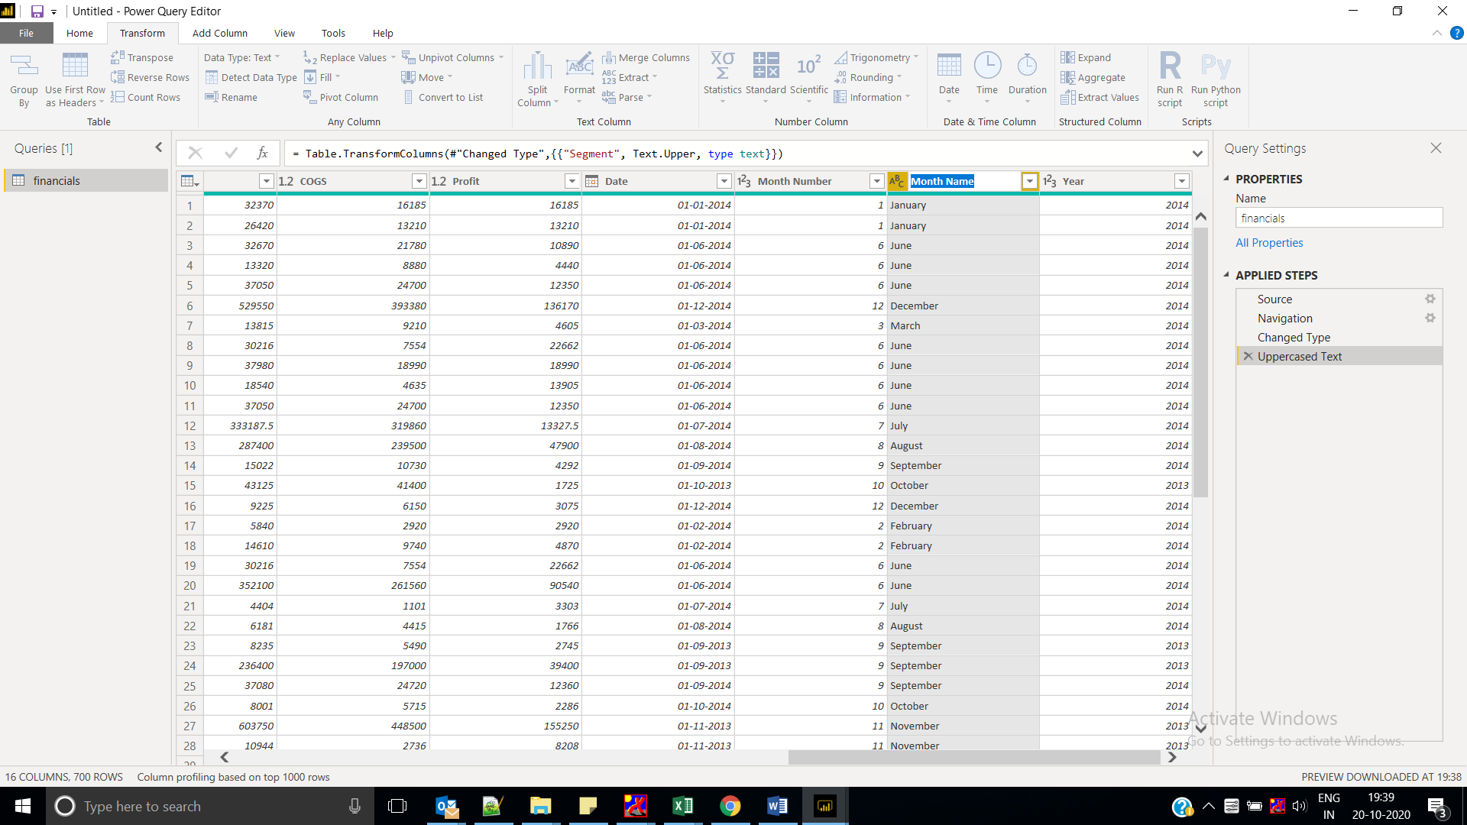

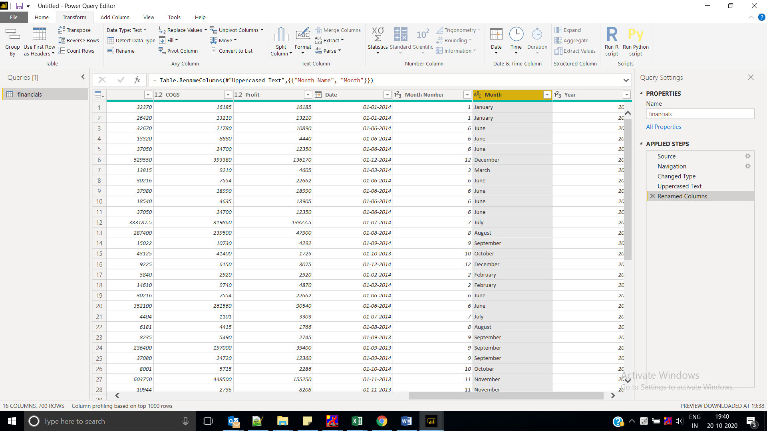

In the **Product** column, select the dropdown and clear the box next to **Velo**.

We know the **Velo** product was discontinued last month, so we want to filter this data from our report to avoid confusion

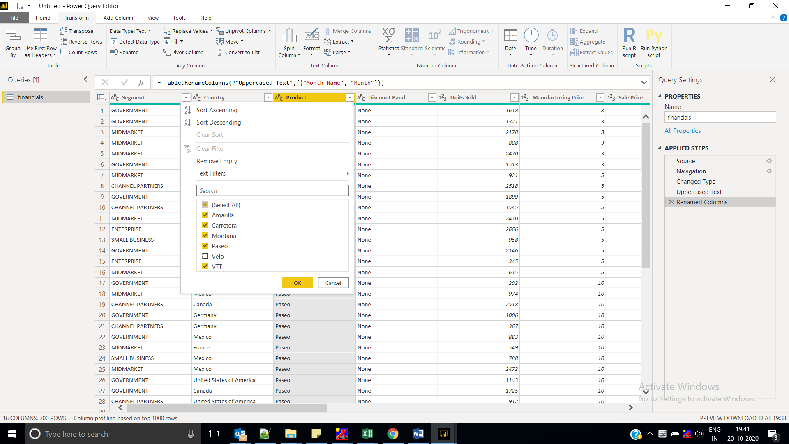

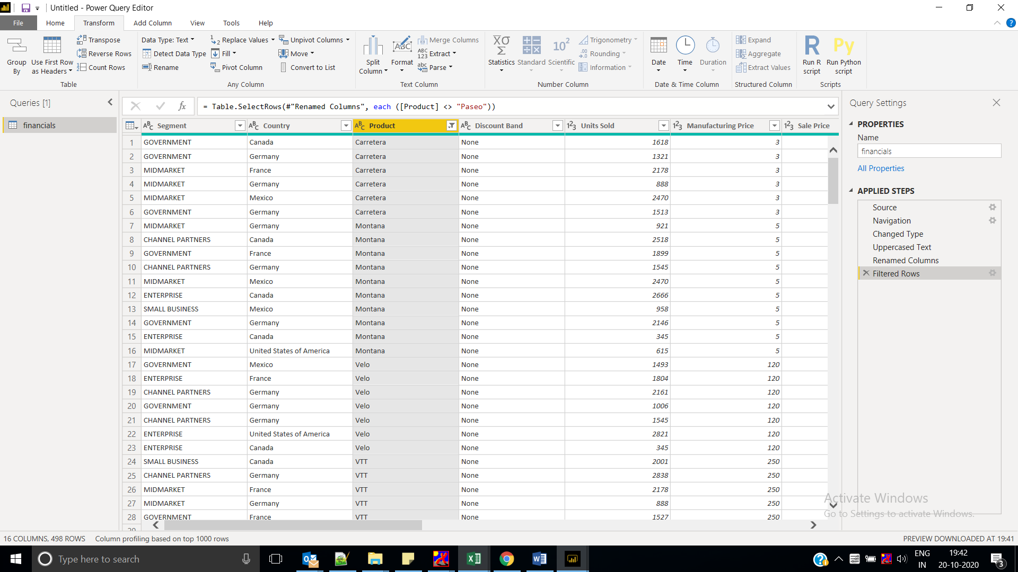

You see that each transformation has been added to the list under **Query Settings** in **Applied Steps**.

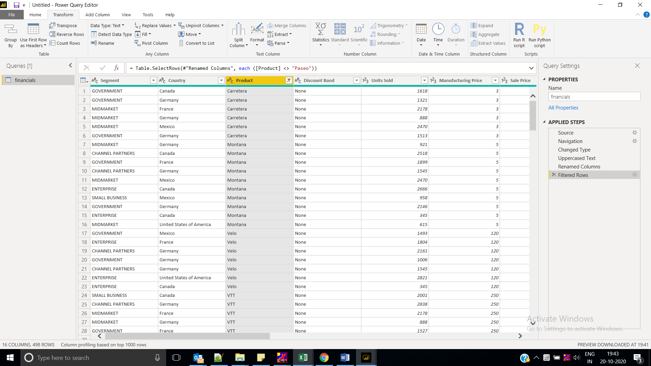

Back on the **Home** tab, select **Close & Apply**. Our data is almost ready for building a report.

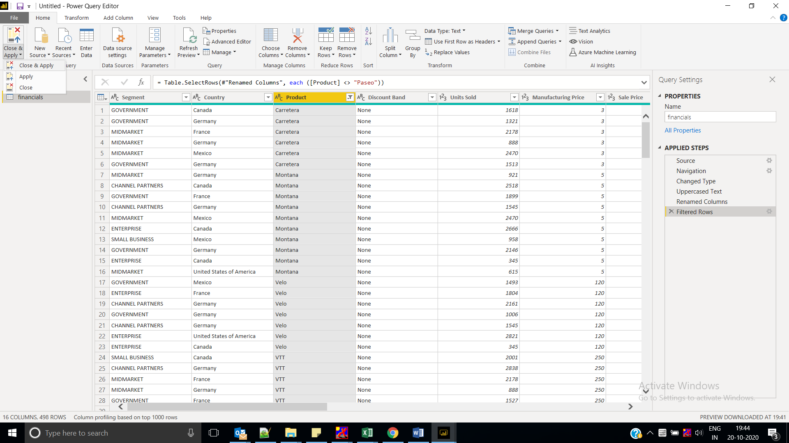

You see the **Sigma symbol** in the Fields list? Power BI has detected that those fields are numeric. Power BI also indicates the date field with a **calendar** symbol.

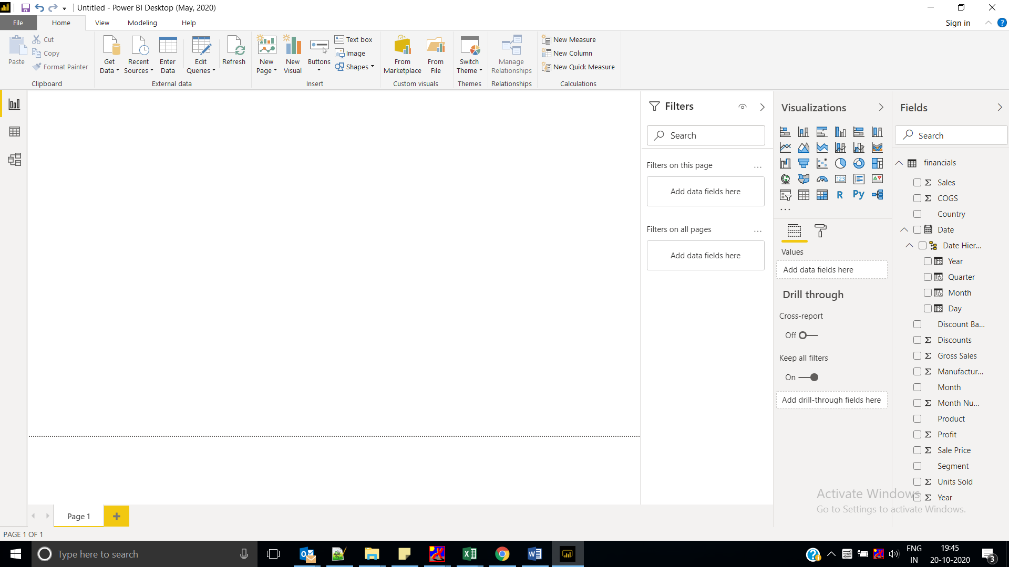

### Write a measure in DAX

1. Select **Data View** on the left.

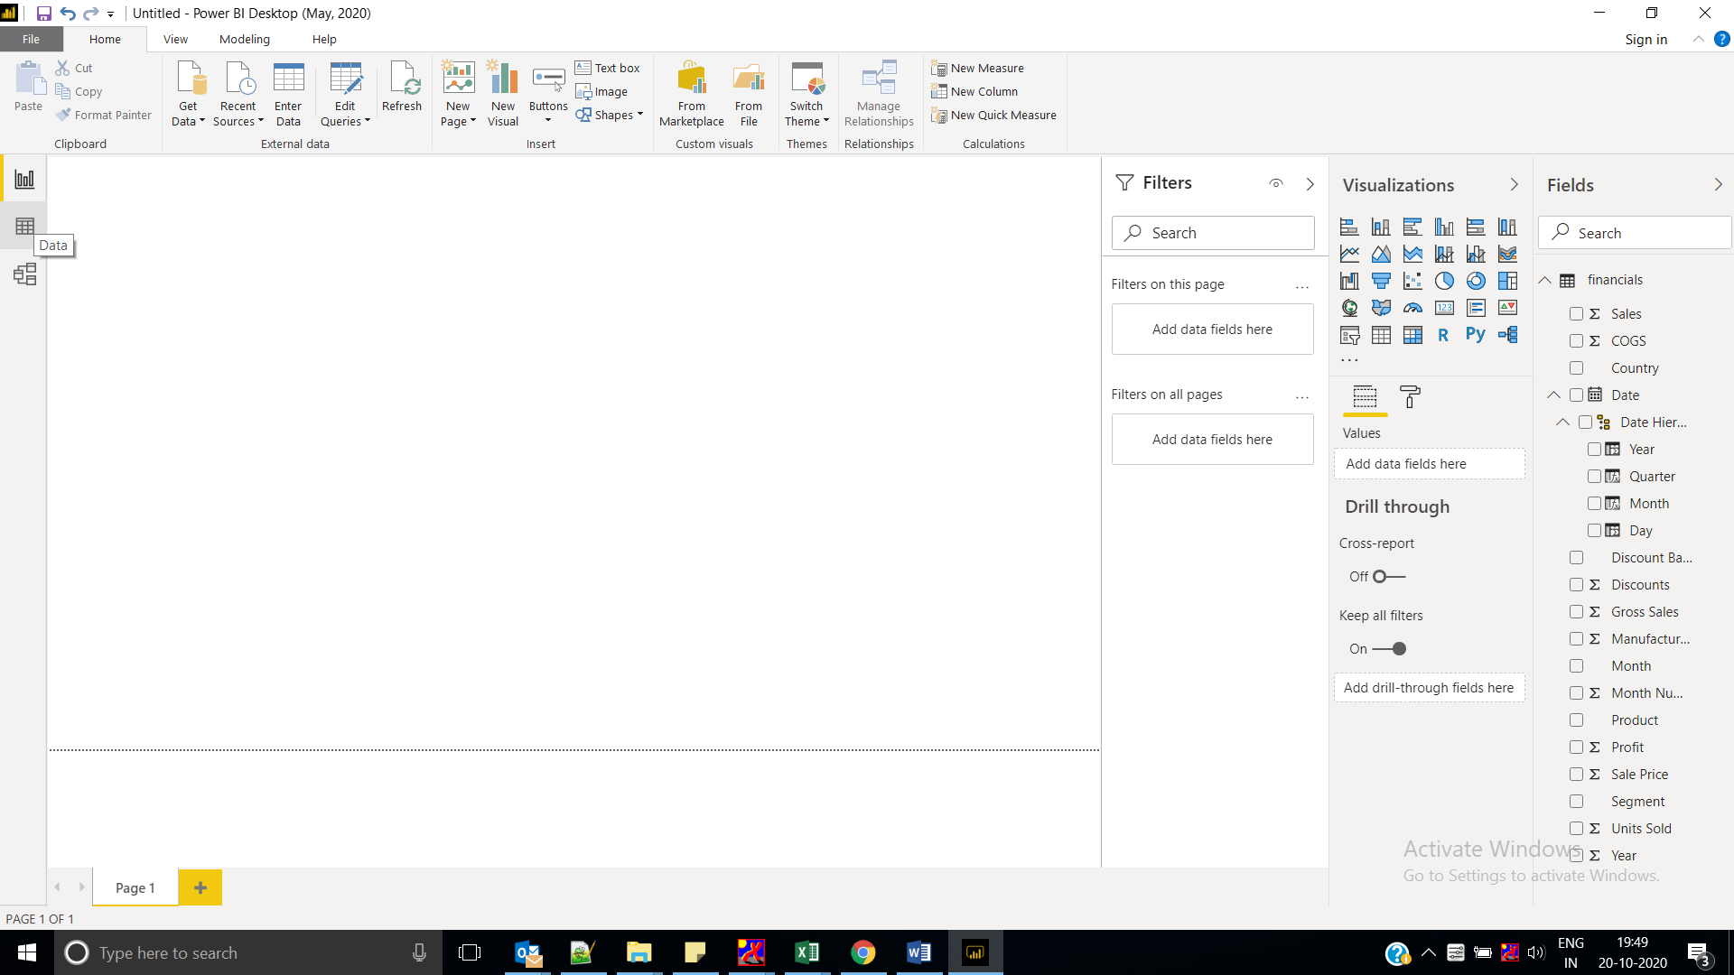

1. On the **Home** ribbon, select **New Table**.

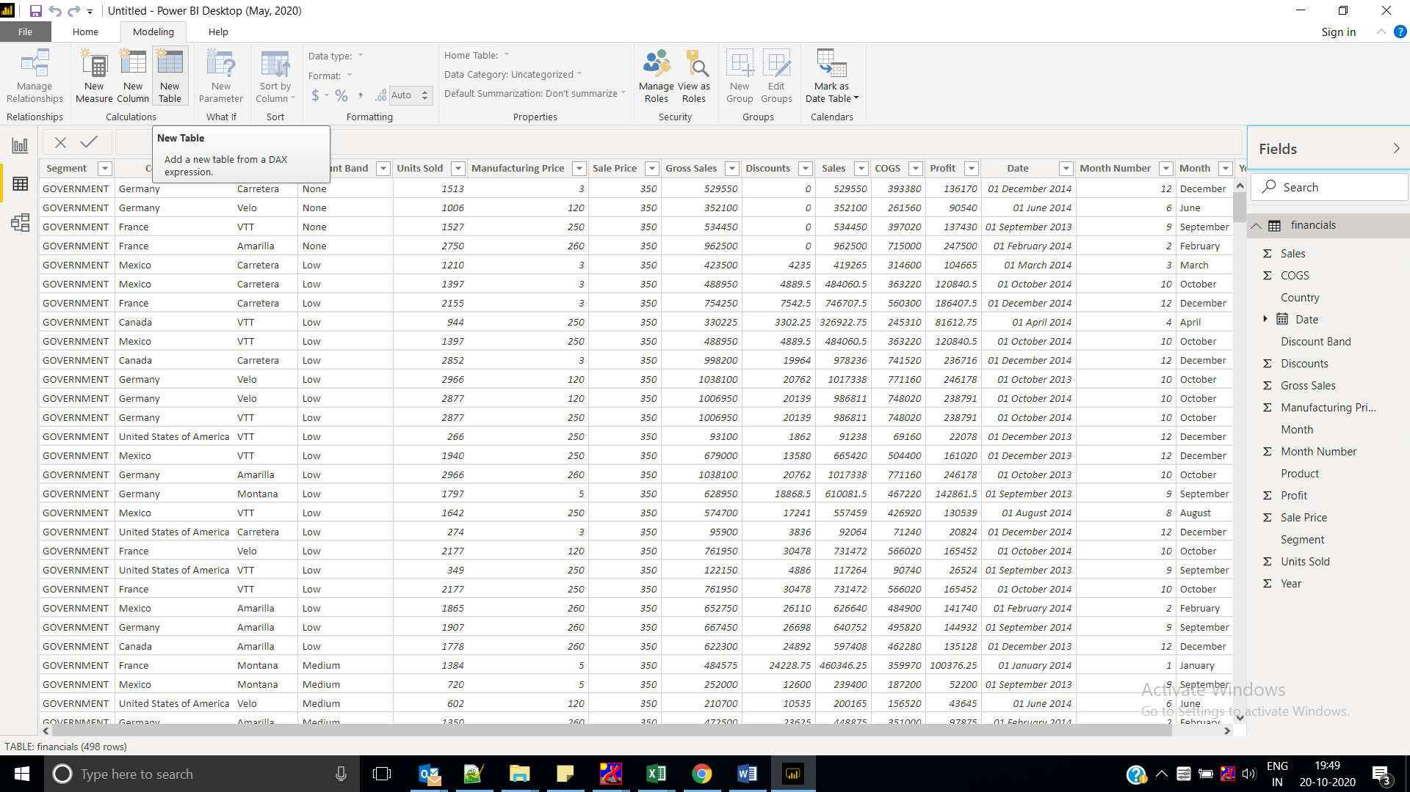

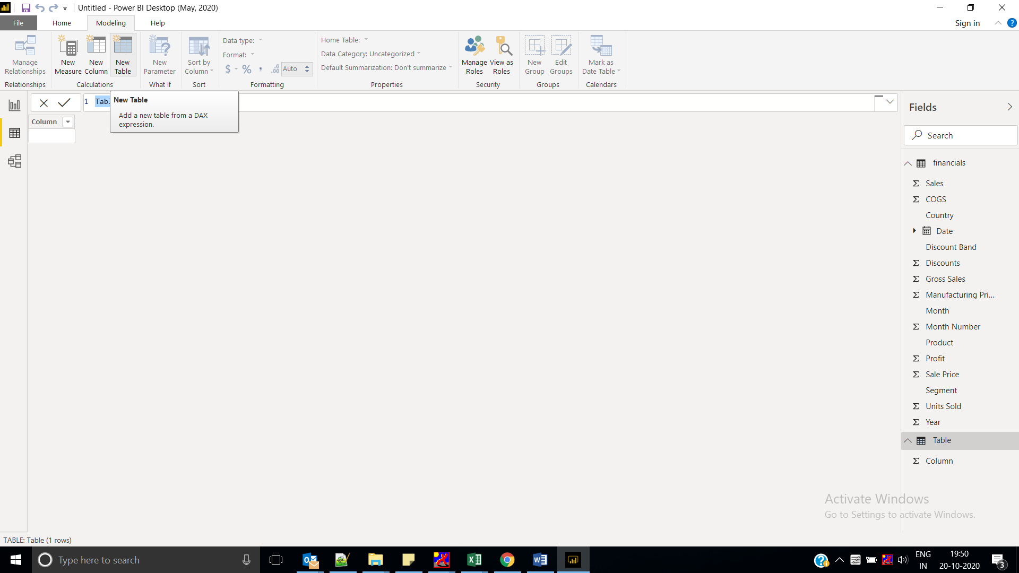

1. Type this measure to generate a Calendar table of all dates between January 1, 2013, and December 31, 2014.

Calendar = CALENDAR(DATE(2013,01,01),Date(2014,12,31))

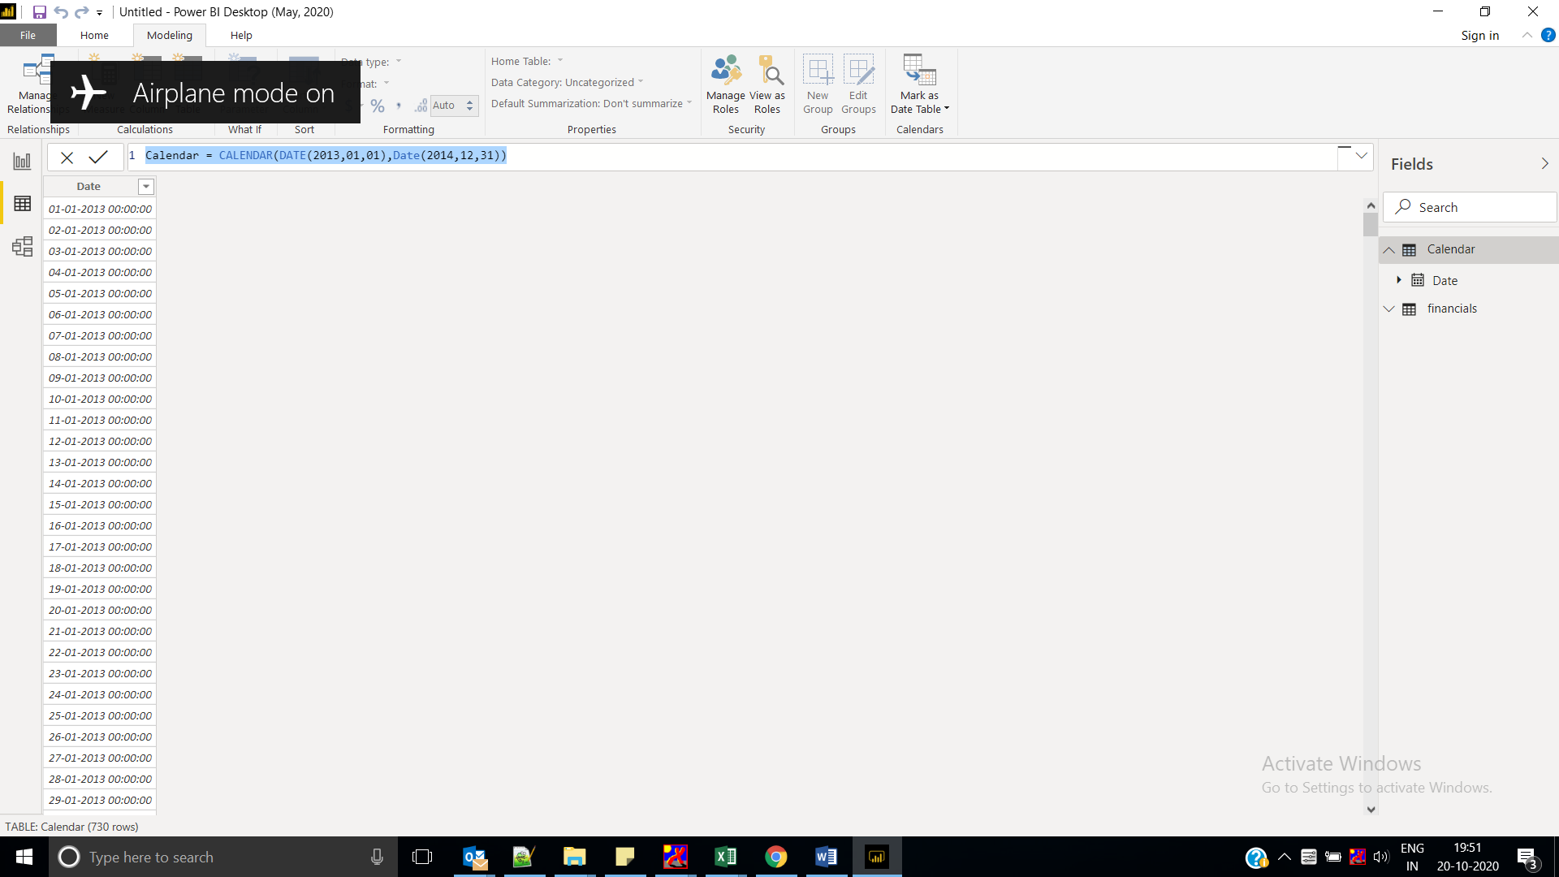

1. Select the check mark to commit.

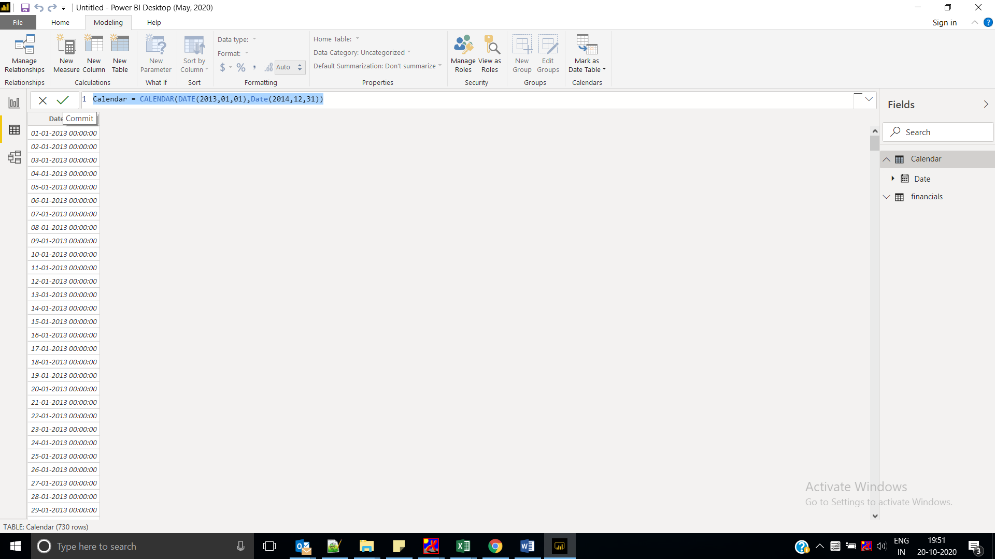

1. Now select **Model View** on the left.

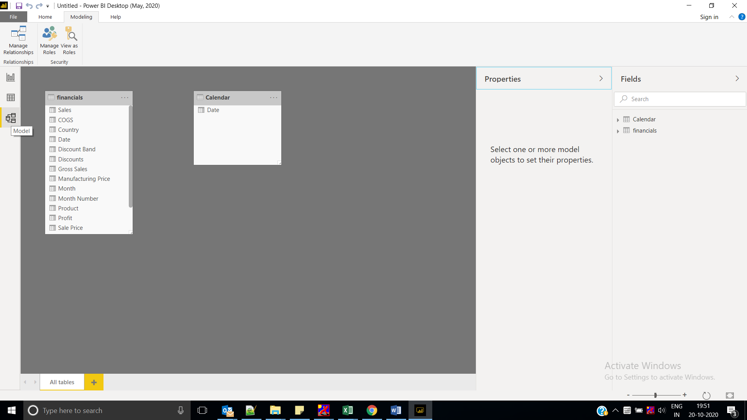

1. Drag the **Date** field from the Financials table to the **Date** field in the Calendar table to join the tables, and create a *relationship* between them.

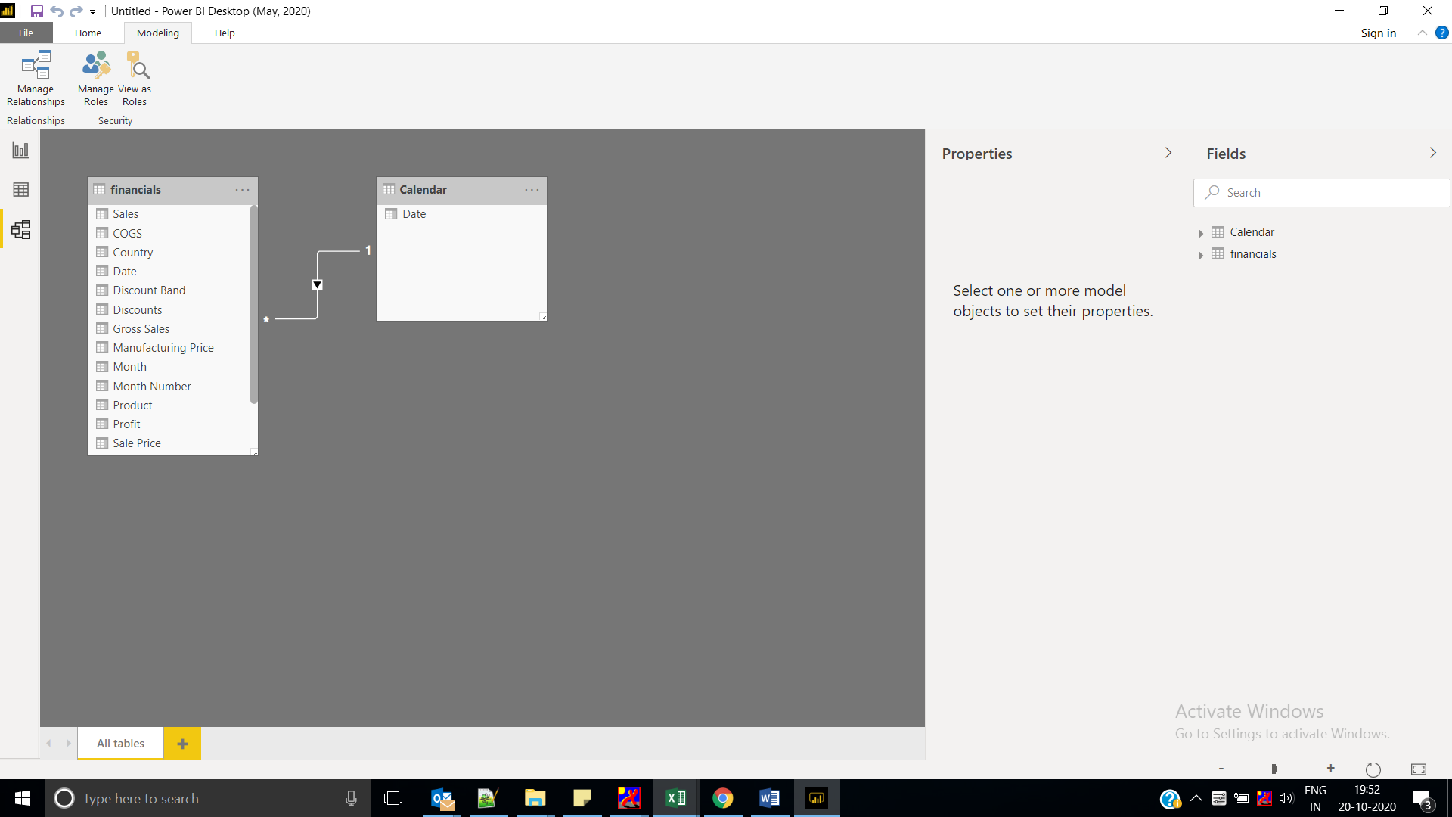

## Build your report

Now select **Report View** on the left 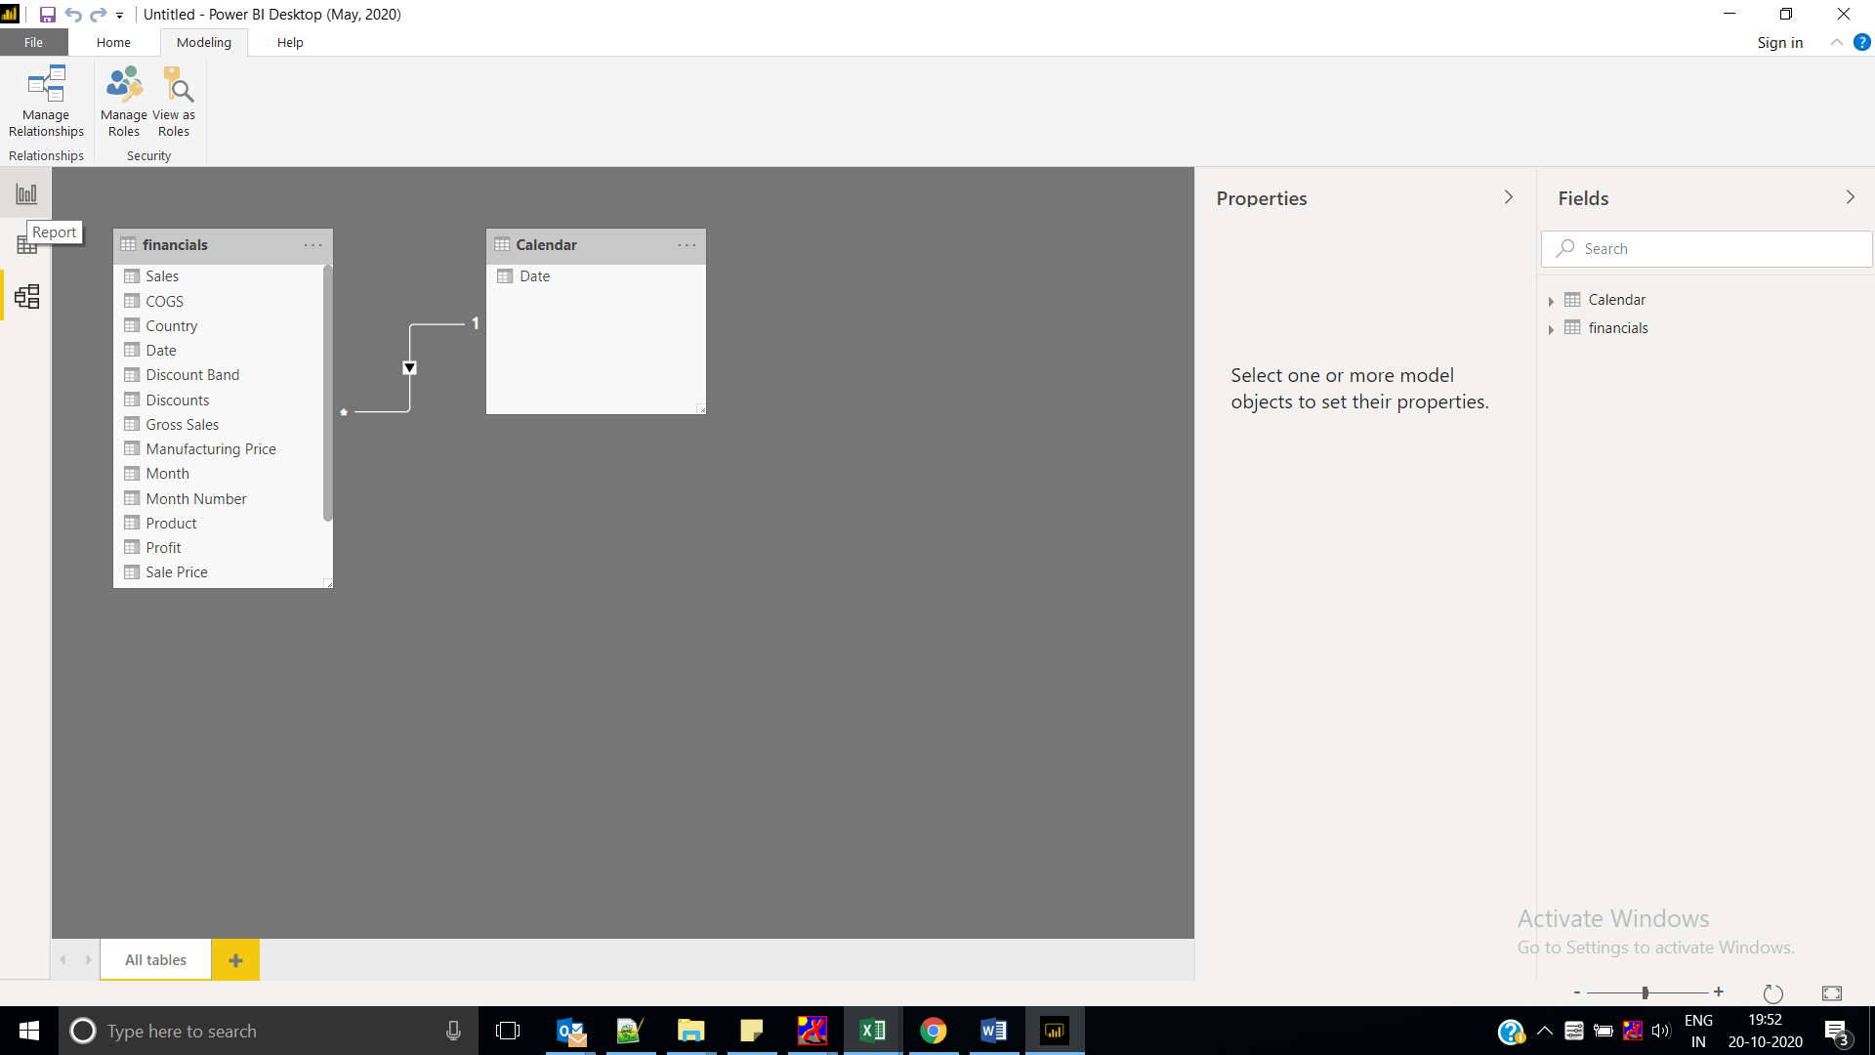

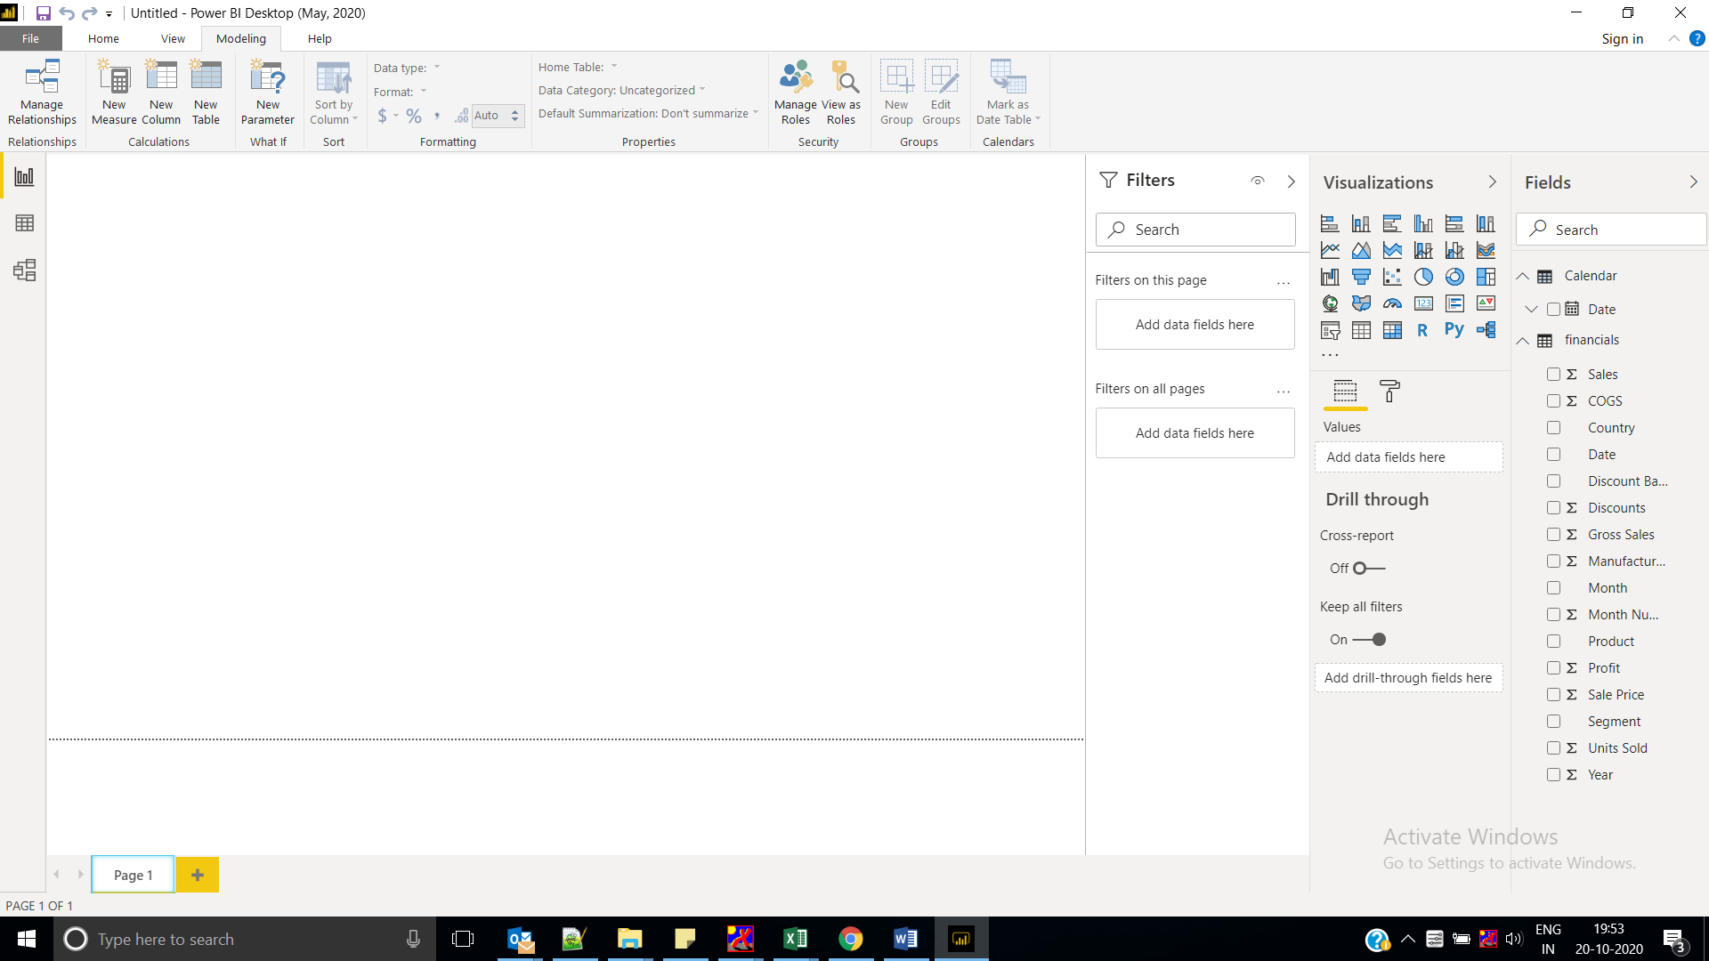

Add slicer

From calendar select year and month

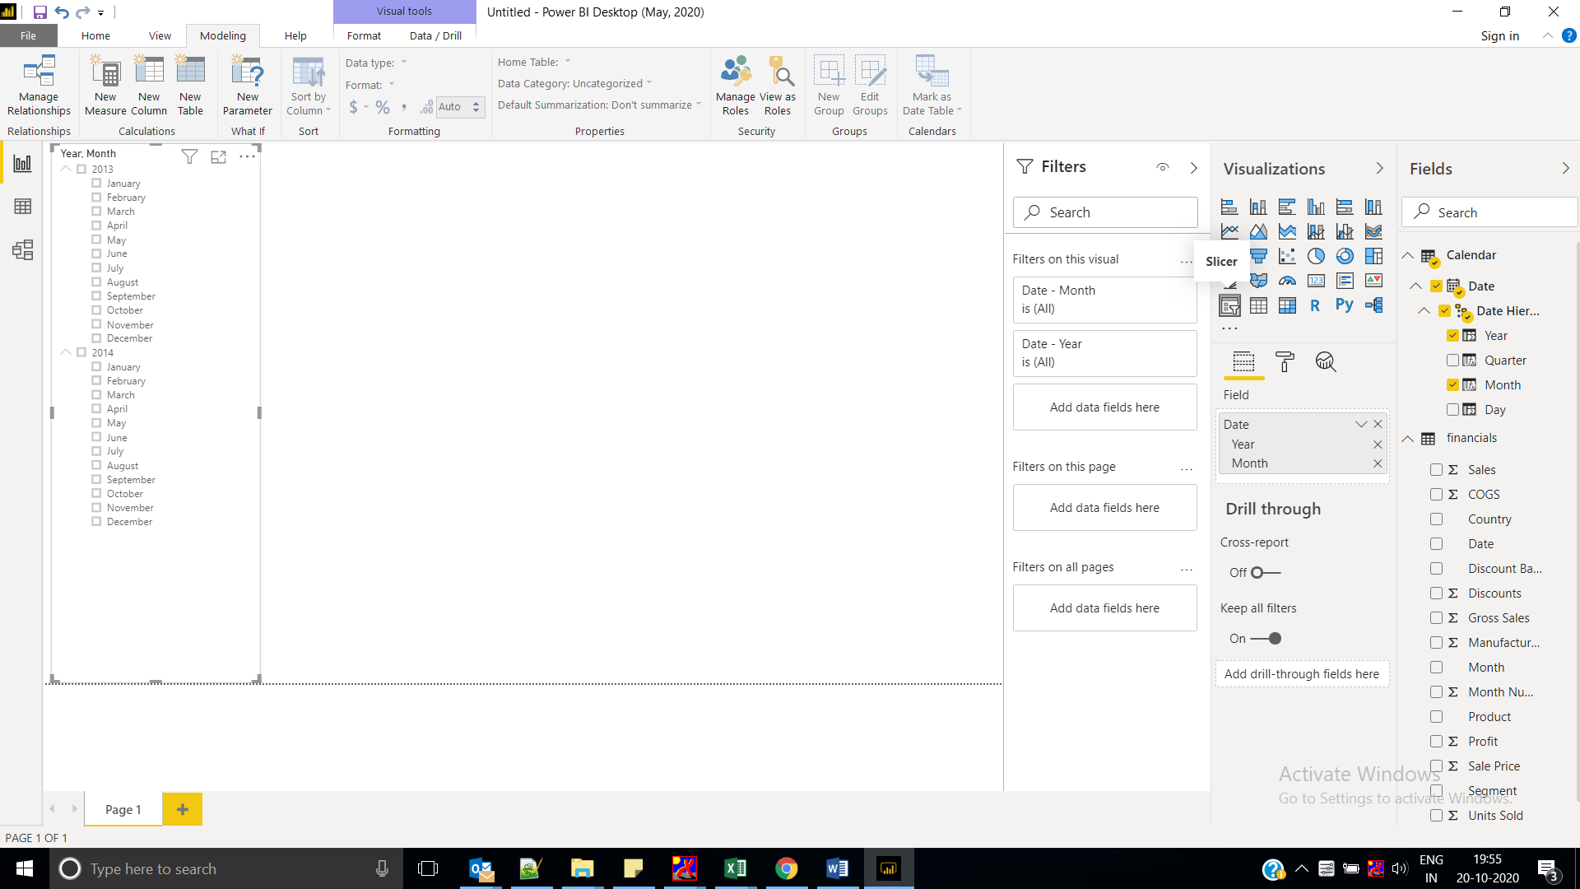

select **Text Box**. Type “Executive Summary – Finance Report”.

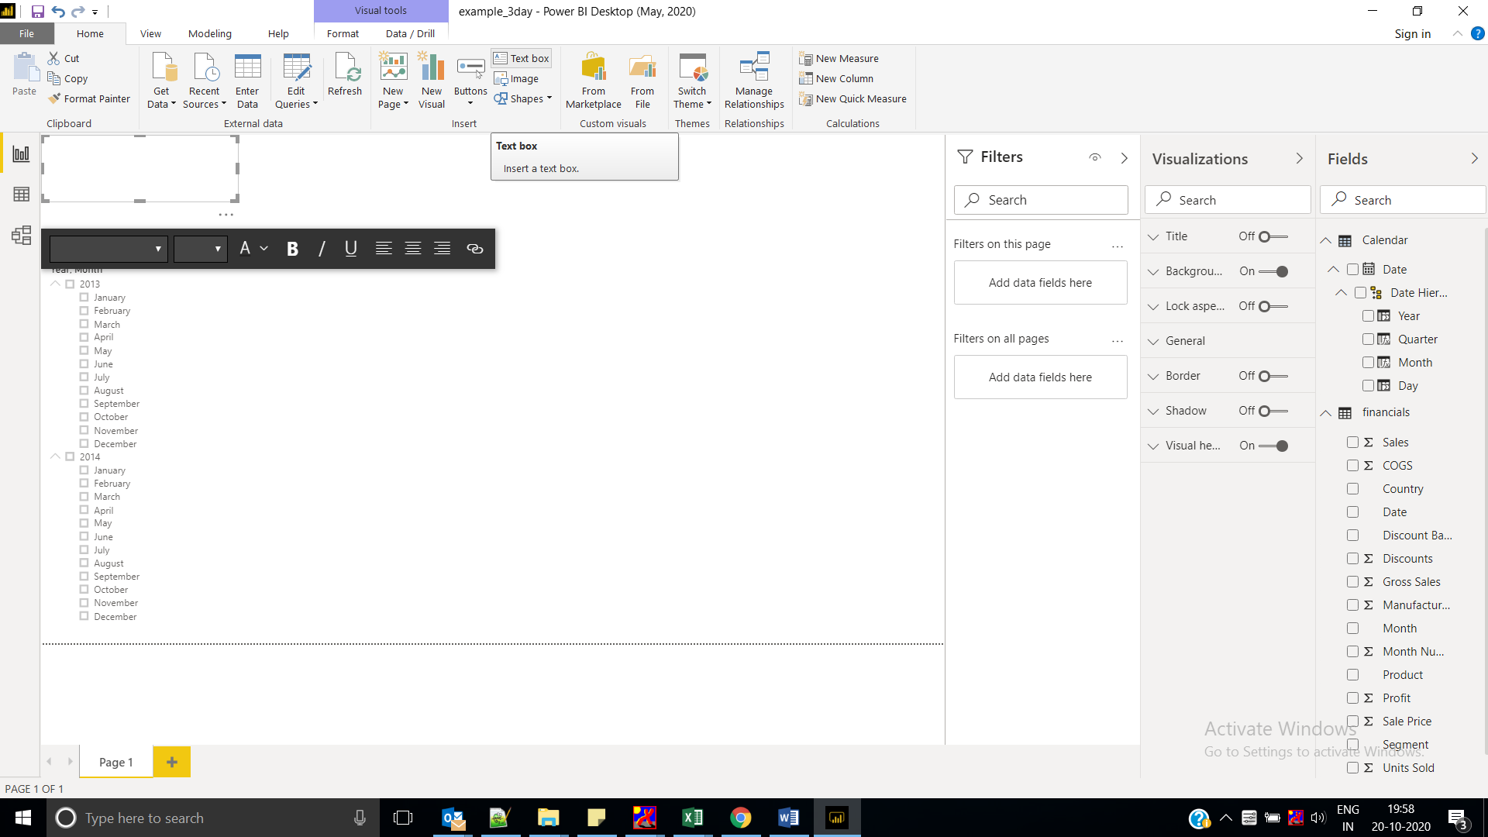

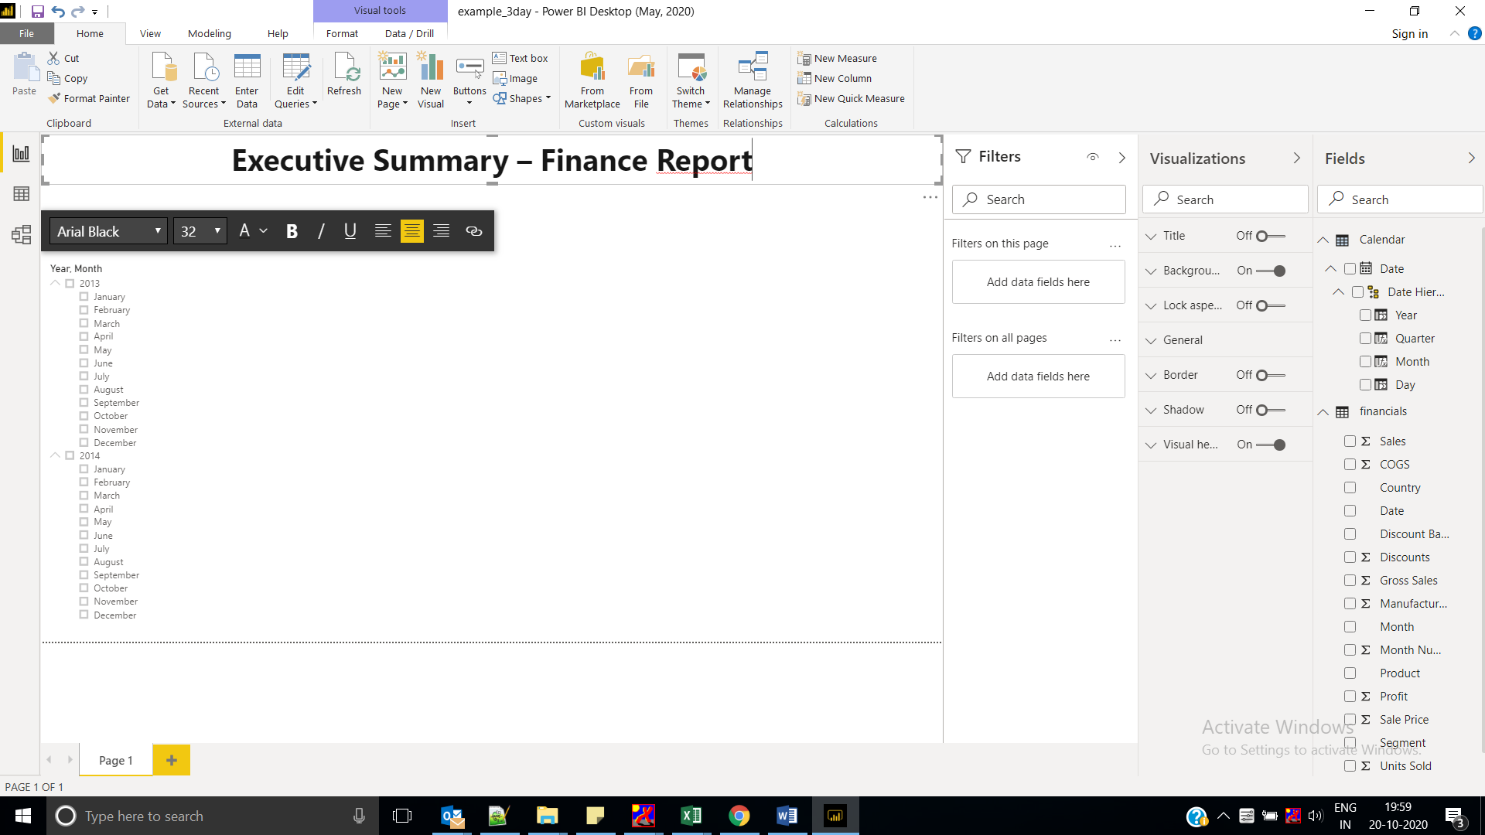

### Visual 2: Profit by Date

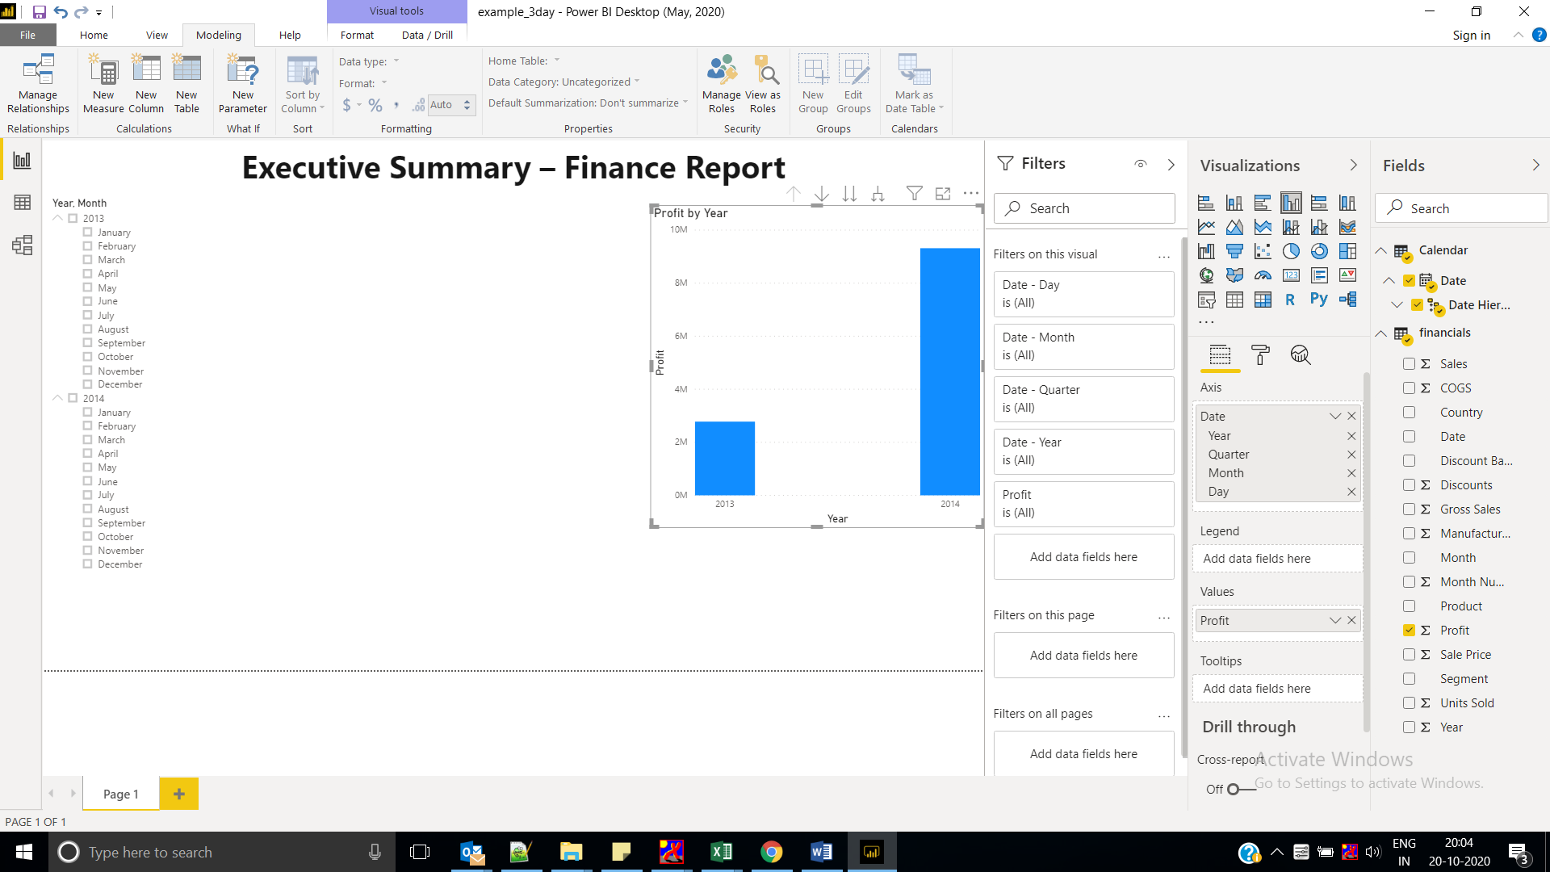

In the **Fields** section of the Visualizations pane, select the drop-down in the **Axis** value. Change **Date** from **Date Hierarchy** to **Date**.

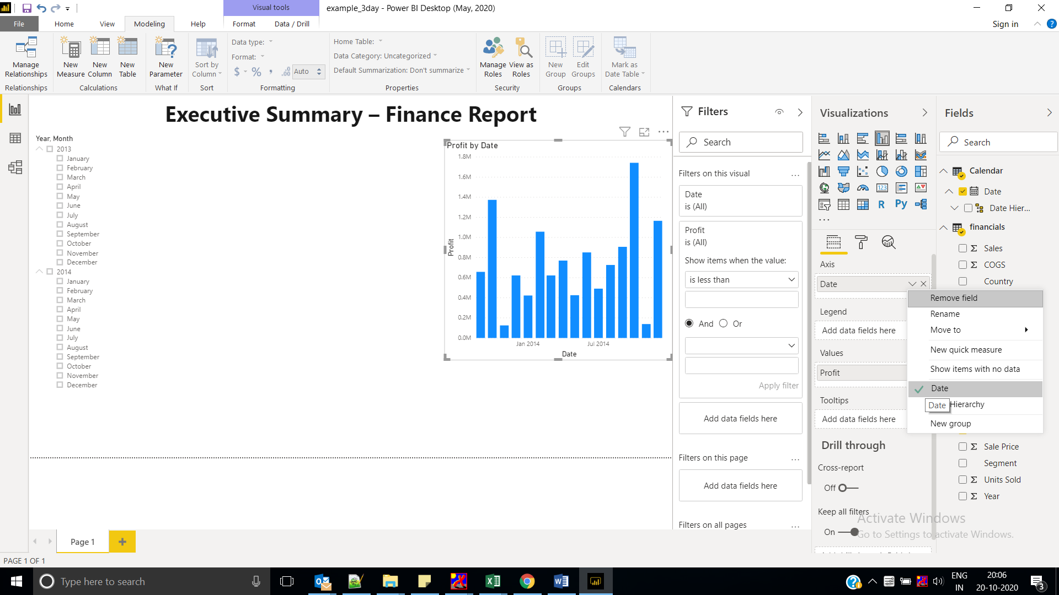

In the Visualizations pane, change the visualization type to **Line chart**.

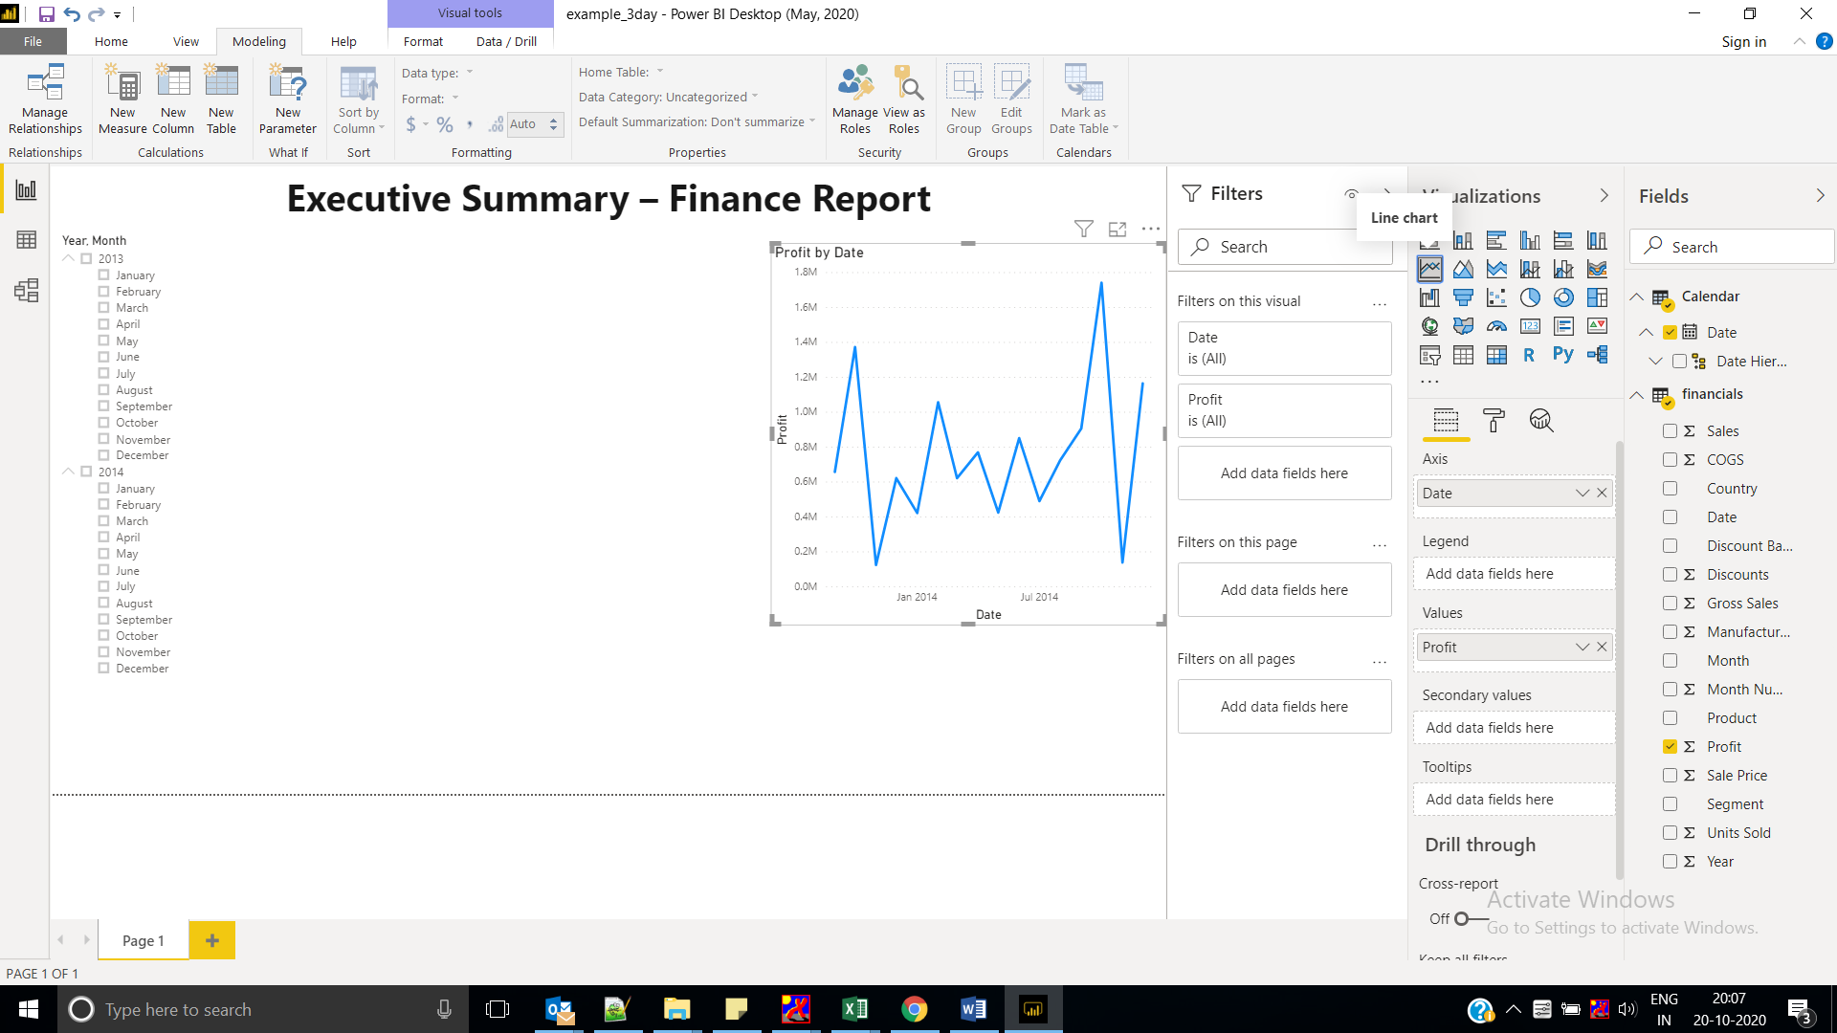

### Profit by Country

Create a map to see which country had the highest profits.

1. From the Fields pane, drag the **Country** field to a blank area on your report canvas to create a map.
2. Drag the **Profit** field to the map.

Power BI creates a map visual with bubbles representing the relative profit of each location.

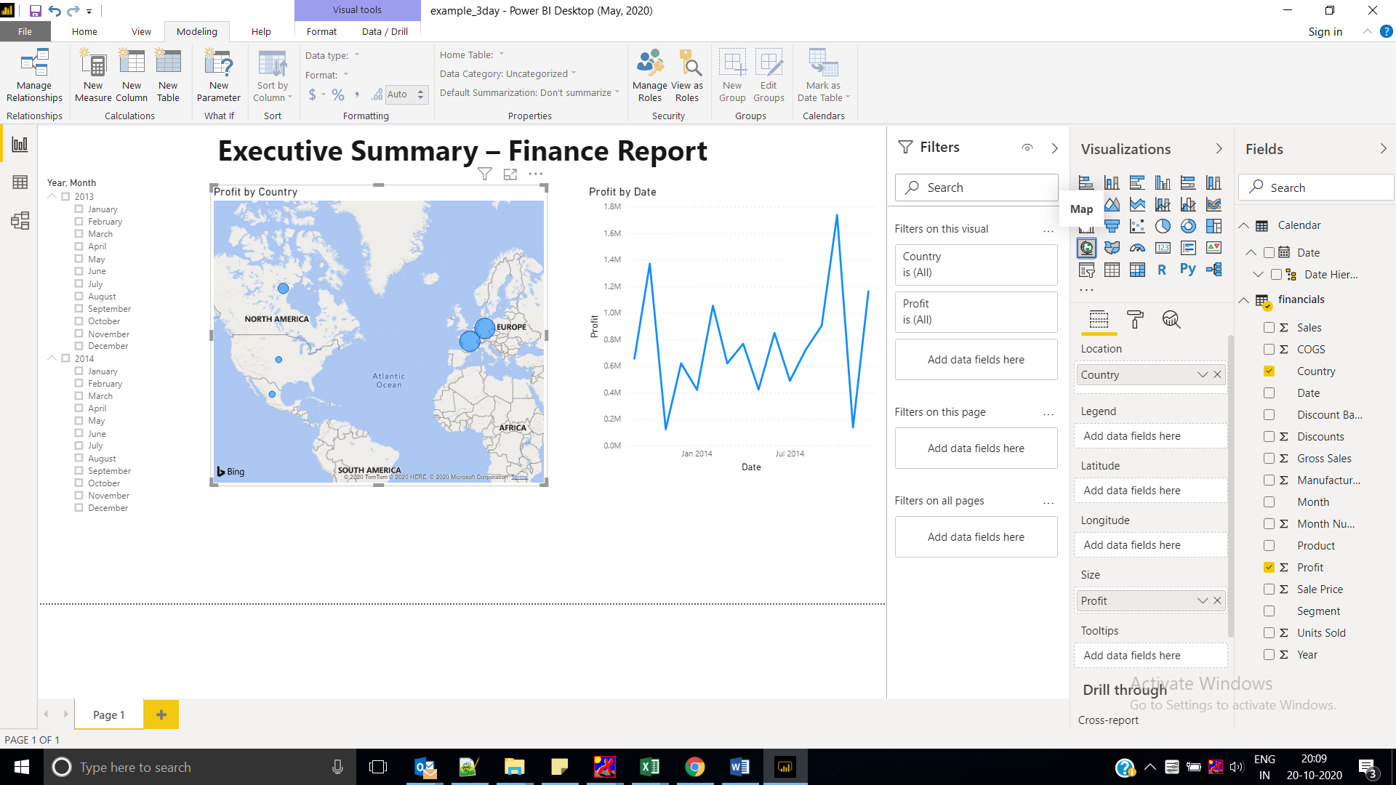

### Sales by Product and Segment

Create a bar chart to determine which companies and segments to invest in.

